烟台双塔食品股份有限公司
Yantai Shuangta Food Co., Ltd.
Jinling Town, Zhaoyuan City, Shandong Province, China, 265404
Tel: (86) 535-8938217 Fax: (86) (86) 535-8938211
PRODUCT DATA SHEET

PRODUCT NAME: MUNG BEAN PROTEIN

No. | Test Item | Test Method | Unit | Specification
1 | Color | Q/YST 0001S-2018 | / | Pale yellow or Milky white
 | Smell |  | / | With right smell of the product, no abnormal odor
 | Character |  | / | Powder or uniform particles
 | Impurity |  | / | No visible impurity
2 | Particle Size | 100 mesh pass | % | ≥95
3 | Moisture | GB 5009.3-2016 (I) | % | ≤10
4 | Protein (dry basis) | GB 5009.5-2016 (I) | % | ≥80
5 | Ash | GB 5009.4-2016 (I) | % | ≤8
6 | pH | GB 5009.237-2016 | / | 6-8
7 | Gluten | Neogen 8510 | mg/kg | ≤20
8 | Soy | Neogen 8410 | mg/kg | ≤20
9 | Total Plate Count | GB 4789.2-2016 (I) | CFU/g | ≤10000
10 | Yeast & Molds | GB 4789.15-2016 | CFU/g | ≤50
11 | Coliforms | GB 4789.3-2016 (II) | CFU/g | ≤30
12 | Salmonella | ISO 6679-1:2017 | /25g | Negative
13 | E. Coli | ISO 7251:2005 | /g | <10
14 | Lead | BS EN ISO 17294-2 2016 mod | mg/kg | ≤1.0
15 | Arsenic | BS EN ISO 17294-2 2016 mod | mg/kg | ≤0.5
16 | Cadmium | BS EN ISO 19294-2 2016 | mg/kg | ≤0.1
17 | Mercury | BS EN 13806:2002 | mg/kg | ≤0.1
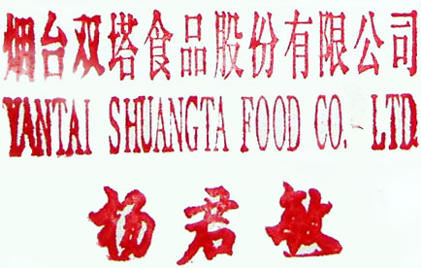
EXPIRY DATE:2 YEARS
STORAGE:KEEP IN DRY PLACE
PAKCKAGE: 15KG/BAG YANTAI SHUANGTA FOOD CO.,LTD
FOR FOOD USE 2020.2.1

